Lab 5: Function Calls

In this lab you’ll be creating functions to perform various financial calculations such as the rate of inflation, the future and present value of investments. The goal is to learn how to develop functions with no parameters, pass by value parameters, pass by reference parameters, and void functions. You’ll be modifying some code that has already been written for you. You can find the code on Sakai attached to this assignment - Lab5.cpp. **Please read the instructions carefully!**

Lab 5a: Write the function *definition* for the inflation function to calculate the rate of inflation given an old price and a new price. The rate of inflation is equal to the difference between the prices divided by the old price. Prompt the user for the old price and the new price inside of the function. **The code you have will not compile until you have at least a skeleton implementation of this function.** Your inflation function will return the rate of inflation, which will then be printed out inside main.

Lab 5b: Write the function *definition* and *call* for the projection function to calculate the future price of an item given the current price, the rate of inflation and the number of years until the purchase. The price, rate, and years are input parameters. So you will need to prompt the user for these values in main(). The future price is equal to:

future price = price * (pow( 1 + rate, years))

**You will print out the future price inside the projection function, rather than returning the answer to main.**

Lab 5c: Write the function to calculate the present value of money discounted into the future. The basic definition is that if you were to be paid $1000 five years from now, what is the equivalent of that money today based on a specific interest rate. This is the converse calculation in part (5b). Use a void function with input parameters of the target amount, the interest rate, and the number of years. Also, there needs to be an output parameter to update the result (remember to use **Pass By Reference**). Prompt for the target amount, rate, and years in main(). Display the present value in main(). The present value is equal to:

PV = targetAmount / pow(1 + rate, years)

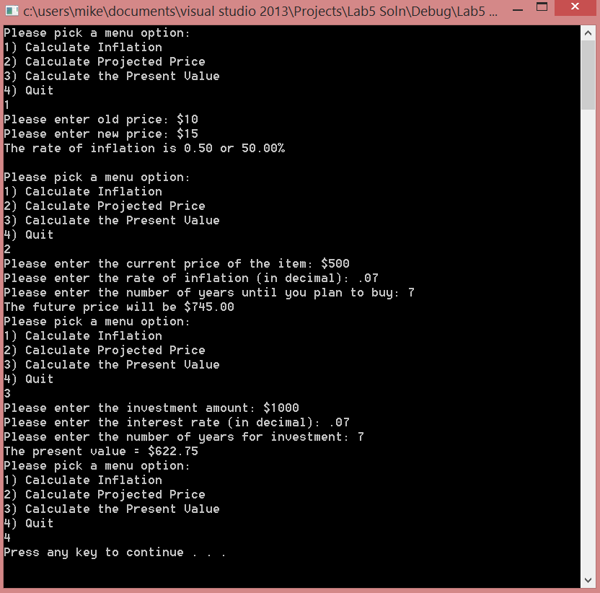

$802.89